**SQL MAJOR ASSIGNMENT**

**Q1. Create a table “Station” to store information about weather observation stations.**

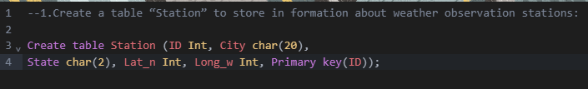

**Q2. Insert the following records into the table.**

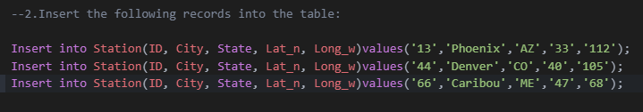

**Q3. Execute a query to look at table STATION in undefined order.**

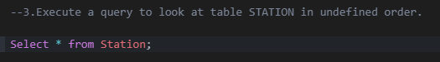

**Result:**

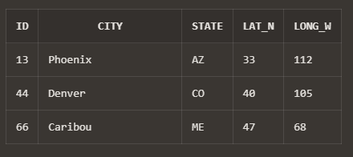

**Q4. Execute a query to select Northern stations(Northern latitude > 39.7).**

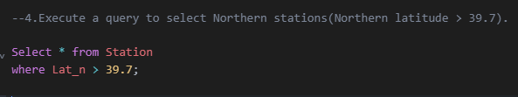

**Result:**

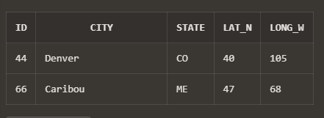

**Q5. Create another table, ‘STATS’, to store normalized temperature and precipitation data.**



**Q6. Populate the table STATS with some statistics for January and July.**

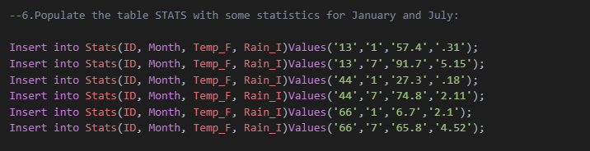

**Q7. Execute a query to display temperature stats(from STATS table) for each city(from Station table).**

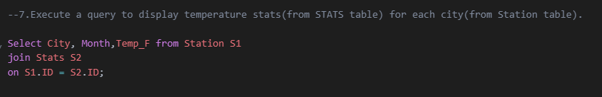

**Result:**

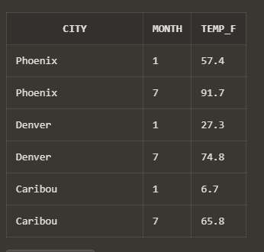

**Q8. Execute a query to look at the table STATS, ordered by month and greatest rainfall, with columns rearranged. It should also show the corresponding cities.**

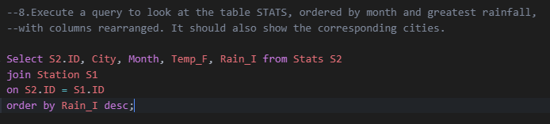

**Result:**

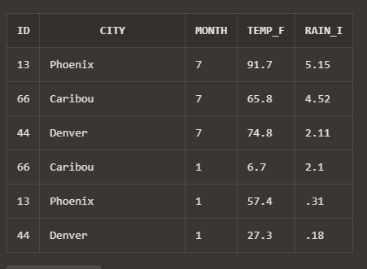

**Q9. Execute a query to look at temperatures for July from table STATS, lowest temperatures first, picking up city name and latitude.**

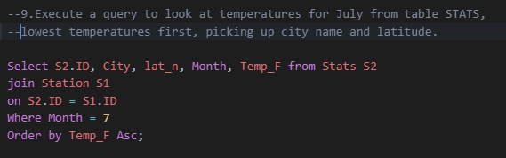

**Result:**

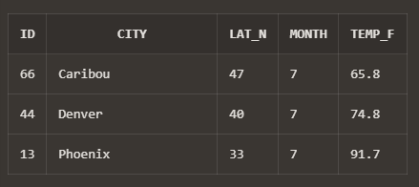

**Q10. Execute a query to show MAX and MIN temperatures as well as average rainfall for each city.**

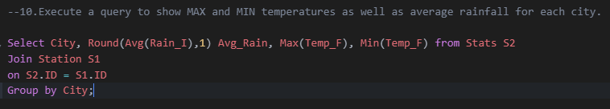

**Result:**

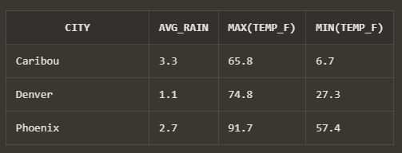

**Q11. Execute a query to display each city’s monthly temperature in Celcius and rainfall in Centimeter.**

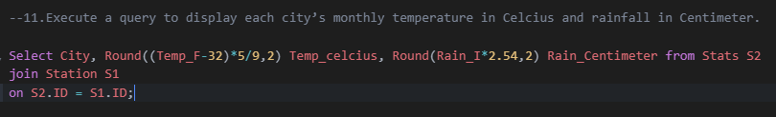

**Result:**

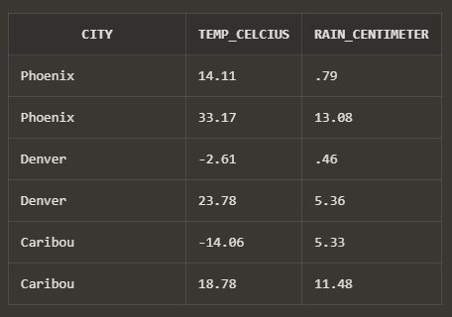

**Q12. Update all rows of table STATS to compensate for faulty rain gauges known to read 0.01 inches low.**

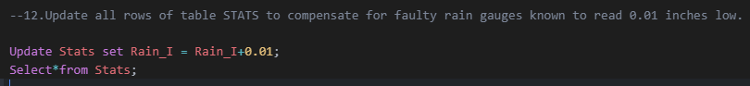

**Result:**

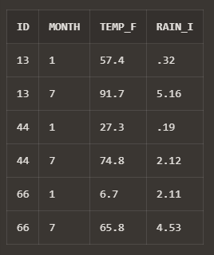

**Q13. Update Denvers July temperature reading as 74.9.**

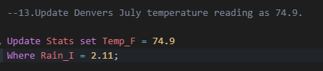

**\*Thank You\***